**9-1 Recitation Activity**

**Basic Triangle Side-Angle Relationships**

**(Yoshiwara Trig 2.2 and 2.4):**

For each of the following, argue why the triangle with given side lengths (lower-case letters) and angle measurements (upper-case letters opposite its lower-case side) is impossible:

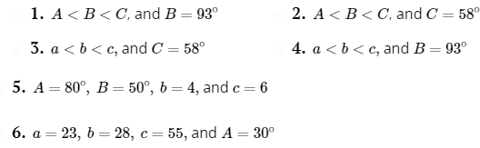

**Basic Right-Triangle Trig:**

**7.** In a given right triangle, $cosθ=3/5$. True or false: One leg of the triangle must be of length 3 and the hypotenuse must be of length 5. If true, argue why it must be true. If it is false, give two other pairs of lengths the side and hypotenuse must be: One pair with shorter lengths and another pair with longer lengths (than 3 and 5).

8. Arguing from the picture alone, which angle has the greater sine, 30° or 50°? Which angle has the greater cosine? Which angle has the greater tangent? (Also for secant, cosecant, cotangent?).

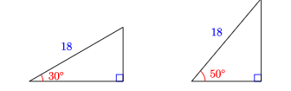

9. For the pictured triangle:

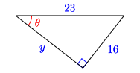

a. Find the length of the unknown side

b. Find the sine, cosine, and tangent of angle .

10. a. For an isosceles right triangle with the two legs of length 1, find the sine, cosine, and tangent of one of the non-right angles.

b. Do the same, but for an isosceles right triangle with legs each of length 5. Do this in two ways (Assuming success in part (a)).

c. What angle did you just find trig values for?

11. a. For an equilateral triangle with side lengths of 1, find the length of the altitude of the triangle.

b. Using the altitude to create a right triangle in the triangle of (a), find the sine, cosine, and tangent of 60°. Do the same for 30°.

12. a. If sin $θ$ = .693, then ____(90° - θ) = .693.

b. If cos 87° = p, then sin______ = p.

13. a. If we have a right triangle with an hypotenuse length of 1, using the Pythagorean Theorem, show that it must be true that $\sin^{2}θ+\cos^{2}θ=1$, where $θ$ is one of the non-right angles in the triangle.

b. Do the same as (a), but if the hypotenuse length is 5.

c. If cos $θ$ = 0.65, use the result of (a) and (b) to find the other trig values of $θ$, assuming they are all positive.

14. A salvage ship is searching for the wreck of a pirate vessel on the ocean floor. Using sonar, they locate the wreck at an angle of depression of 36.2°. The depth of the ocean at their location is 260 feet. How far should they move so that they are directly above the wrecked vessel?

15. To measure the distance across a canyon, Evel first sights an interesting rock directly opposite on the other side. He then walks 200 yards down the rim of the canyon and sights the rock again, this time at an angle of 18.5° from the canyon rim. What is the width of the canyon?

16. (APC p. 222) Supertall high rises have changed the Manhattan skyline. These skyscrapers are known for their small footprint in proportion to their height. Suppose that a relatively short supertall has been built to a height of 635 feet, as pictured below, and that a second supertall is built nearby. Given the two angles that are computed from the new building, how tall, s, is the new building, and how far apart, d, are the two towers?

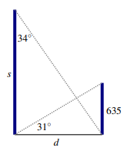

17. (APC p. 222) Surveyors are trying to determine the height of a hill relative to sea level. First, they choose a point to take an initial measurement with a sextant that shows the angle of elevation from the ground to the peak of the hill is 19° . Next, they move 1000 feet closer to the hill, staying at the same elevation relative to sea level, and find that the angle of elevation has increased to 25° , as pictured below. We let h represent the height of the hill relative to the two measurements, and x represent the distance from the second measurement location to the “center” of the hill that lies directly under the peak. Find x and h.

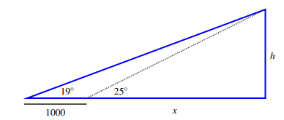

18. What is the geometric purpose of trigonometry? Hint: Think about what attribute an angle measures and how that attribute is different from that of what a length (or area or volume) measures.